Methodology 2

Raw Data Sources 2

Data Preparation 2

***Creating mainland layer of Singapore (excluding secondary islands)*** 2

***Creating Choropleth Map of Primary School Students in Each Subzone*** 5

***Creating all_primary_schools layer*** 6

***Creating closed_primary_schools layer*** 8

***Creating current_primary_schools layer*** 9

***Creating Choropleth Map of Schools in each Subzone*** 9

***Creating walking layer*** 11

***Creating privatedriving layer*** 12

***Creating hex_residentials and hex_residentials_centroids layer*** 12

Data Cleaning 15

***Find the Relative Student to School Ratio in Subzones*** 15

***Find the Number of Affected Residentials*** 15

***Create Buffers for Affected Residentials*** 21

***Create Shortest Paths for Affected Residentials*** 22

***Find and Calculate the Number of Primary Schools Accessible by Buffers (1km_affected)*** 24

***Find and Calculate the Number of Primary Schools Accessible by Walking the Shortest (1km_affected)*** 27

***Find and Calculate the Number of Primary Schools Accessible by Driving the Shortest (1km_affected)*** 27

Results and Discussion 28

Data Analysis 28

***Subzone Analysis of Students to School Ratio*** 28

***Number of Affected Residentials due to Merger*** 30

***Number of Schools Accessible after the Merger*** 31

Limitations 32

***Calculation of Affected Residentials*** 32

***Use of (Centroids of) Hexagonal Grids to Represent Affected Residentials*** 32

***Method of finding Shortest Path and Fastest Time*** 32

Lessons Learnt 33

Future Works 33

References 35

Methodology

# Raw Data Sources

|  |  |  |
| --- | --- | --- |
| **File name** | **File Format** | **Link to data source** |
| Singapore Residents by Planning Area / Subzone, Single Year of Age and Sex, June 2011-2020 | csv | <https://www.singstat.gov.sg/-/media/files/find_data/population/statistical_tables/respopagesex2011to2020.ashx> |
| master-plan-2019-subzone-boundary-no-sea | kml and geojson | <https://data.gov.sg/dataset/master-plan-2019-subzone-boundary-no-sea> |
| malaysia-singapore-brunei-latest-free | shapefile | <https://download.geofabrik.de/asia/malaysia-singapore-brunei.html> |
| school-directory-and-information | csv | <https://data.gov.sg/dataset/school-directory-and-information> |

# Data Preparation

Before we begin, ensure that your QGIS active window has the correct projected coordinates system: EPSG: 3414. For all subsequent layers used, do save them in 3414 before processing.

## Creating mainland layer of Singapore (excluding secondary islands)

1. Under your Browser panel, look for **master-plan-2019-subzone-boundary-no-sea-kml.kml** and add **URA_MP19_SUBZONE_NO_SEA_PL** to your Layers panel. The layer should look like this:

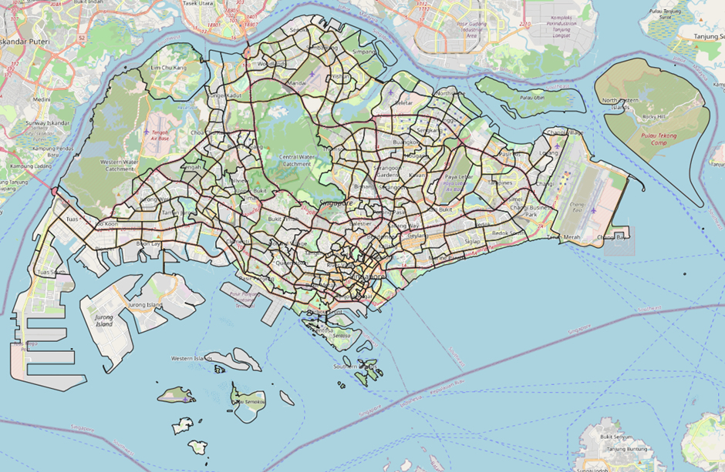

1. Use the *Select Features by Freehand* tool to draw out the mainland of Singapore like below:

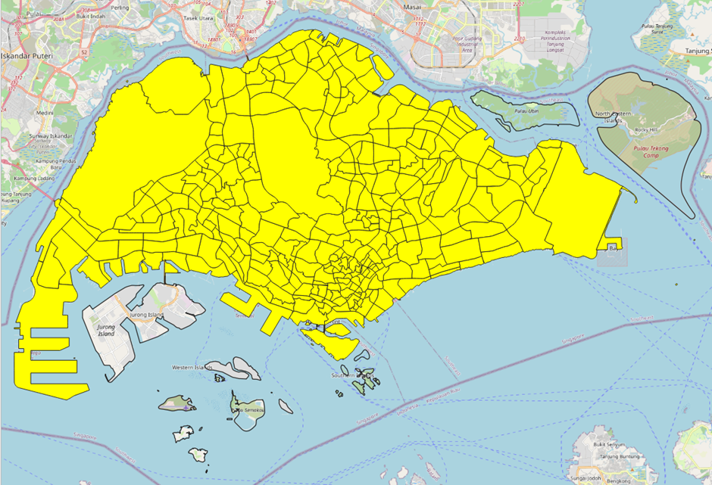

1. On your Layers panel, click Export -> *Save Selected Features As*
2. Create new GeoPackage folder, **Project**, and name the new layer as **mainland**
3. Remove the raw data layer, **URA_MP19_SUBZONE_NO_SEA_PL,** that was downloaded as we have our new **mainland** layer

Creating Primary School Students by Subzone layer

1. Load **respopagesex2011to2020** layer onto Layers panel
2. Under Database menu bar, select *DB Manager* and execute the following query:

select "SZ", "Age", sum ("Pop") as "POP2019"

from respopagesex2011to2020

where "Time" = '2019'

group by "SZ", "Age"

1. Load the executed query as a new layer and untick geometry
2. Use *Select by Expression* tool in the attribute table to select:

Age in (7,8,9,10,11,12)

1. Use *Field Calculator* tool, create a new field containing Subzone names in uppercase:

Upper(“SZ”)

1. *Save Selected Feature* as **prisch_student_sz**, untick geometry
2. Open mainland layer and *join table*

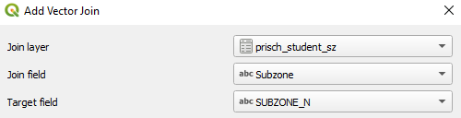

1. Save the joined layer as **mainland_joined**
2. Use *Select by Expression* tool in the attribute table to select:

"prisch_student_sz_POP2019" is null

1. Use *Field Calculator* to update **mainland_joined**’s existing field NULL values to 0

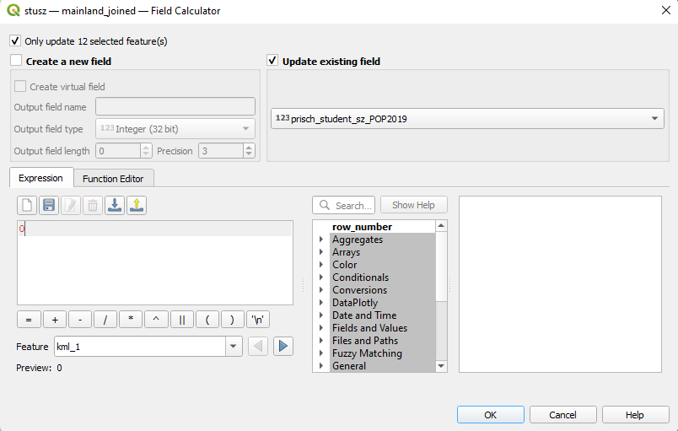

1. Save the layer as **mainland_with_student**

## Creating Choropleth Map of Primary School Students in Each Subzone

1. Double-click on **mainland_with_student,** select **Symbology**
2. Select **Graduated**

Value: prisch_student_sz_POP2019

Mode: Natural breaks (Jenks)

1. Click on Classify

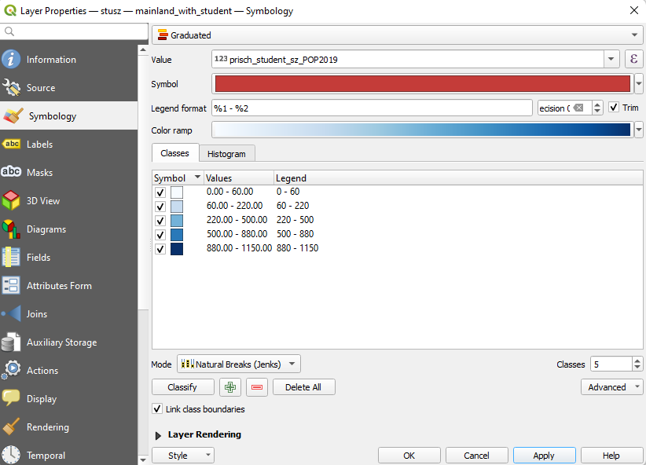

1. Return to your QGIS active window. Your map should look like the following

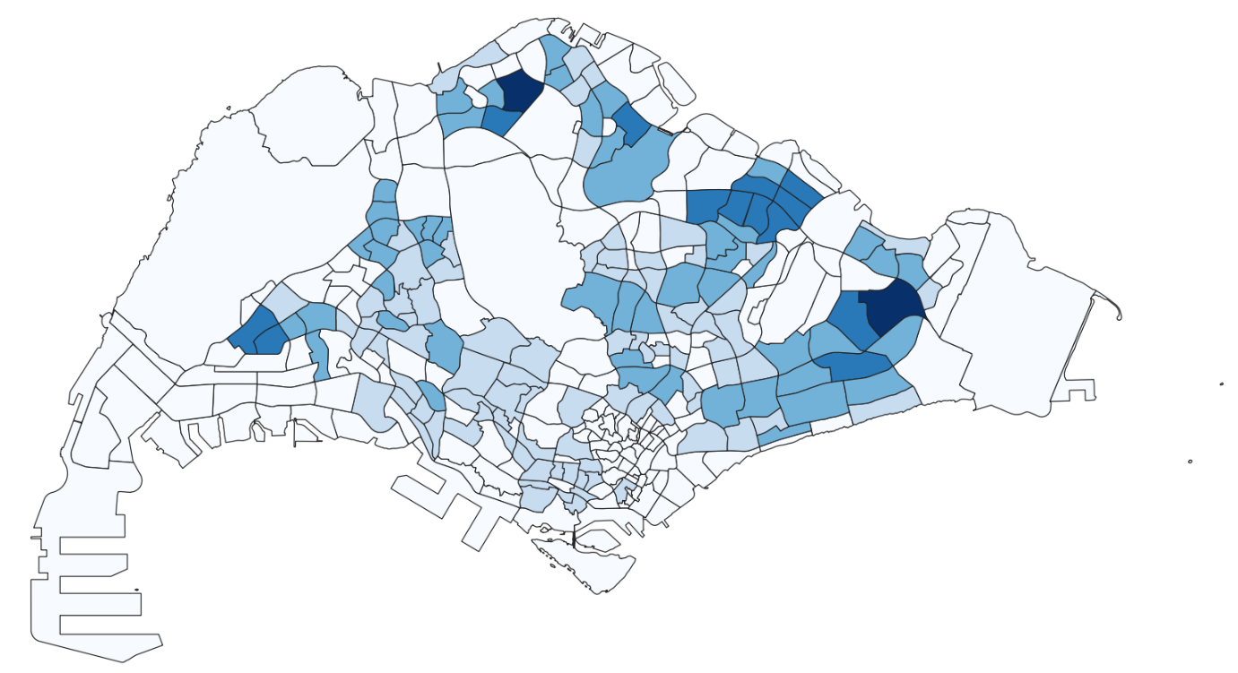

## Creating all_primary_schools layer

With the current **school-directory-and-information.csv** file, the 7 closed schools have been removed. We need to manually add their school name, address, and postal code into the CSV file. We can find these on Google.

For us to geocode our school points onto our **mainland** layer more accurately, we need to modify **school-directory-and-information.csv** to include the x and y coordinates. We can use SLA OneMap API to help us. Read the code chunks below into your RStudio environment. Enter the lines in blue into your console.

url<-"https://developers.onemap.sg/commonapi/search"  
csv<-read_csv("csv/school-directory-and-information.csv")

Rows: 353 Columns: 13  
── Column specification ────────────────────────────────────────────────────────  
Delimiter: ","  
chr (12): school_name, address, mrt_desc, bus_desc, dgp_code...

dbl (1): postal_code  
ℹ Use `spec()` to retrieve the full column specification for this data.  
ℹ Specify the column types or set `show_col_types = FALSE` to quiet this message.

postcodes<-csv$`postal_code`  
found<-data.frame()  
not_found<-data.frame()  
  
for(postcode **in** postcodes){  
 query<-list('searchVal'=postcode,'returnGeom'='Y','getAddrDetails'='Y','pageNum'='1')  
 res<- GET(url,query=query)  
   
 **if**((content(res)$found)!=0){  
 found<-rbind(found,data.frame(content(res))[4:13])  
 } **else**{  
 not_found = data.frame(postcode)  
 }  
}  
  
merged = merge(csv,found, by.x = 'postal_code', by.y = 'results.POSTAL', all = TRUE)  
write.csv(merged, file = 'csv/found.csv')  
write.csv(not_found, file = "csv/not_found.csv")

Now that we have more complete csv file, **found.csv**, we can add it in our QGIS as a point layer

1. Under the Layer menu bar, select Add Layer -> Add Delimited Text Layer
2. Select the **found.csv** that you’ve just created and fill up the rest accordingly. Ensure that your Geometry CRS is in 3414.

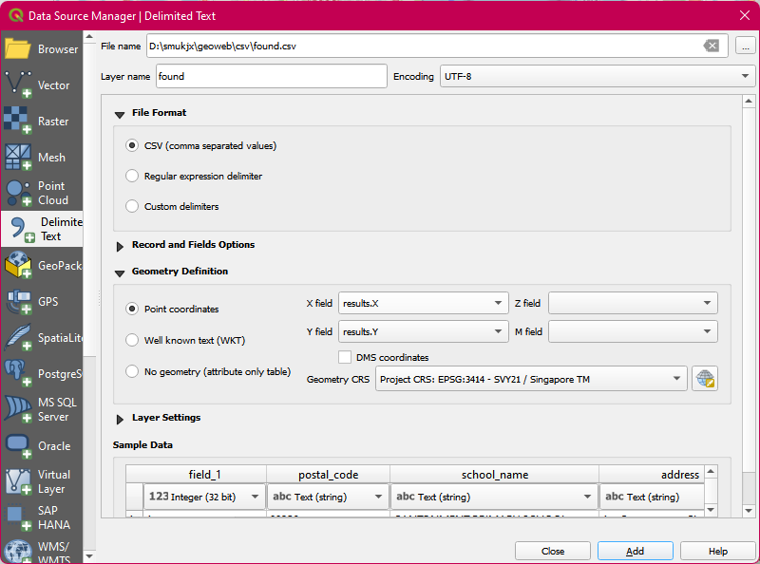

1. A new layer, **found**, will be added to your Layers panel. Save the layer into your **Project** Geopackage as **geocoded_schools**
2. Open the attribute table of **geocoded_schools**. Use *Select by Expression* tool to filter only the primary schools. You should have 194 selected features, with 3 rows having NULL for column results.

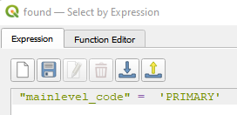

1. *Save Selected Features* As **all_primary_schools** into your **Project** GeoPackage
2. Open the *attribute table* of **all_primary_schools**
3. Under the *school_name* field, look for MACPHERSON PRIMARY SCHOOL
4. Enable the *Toggle Editing* tool and delete away one of the duplicated row

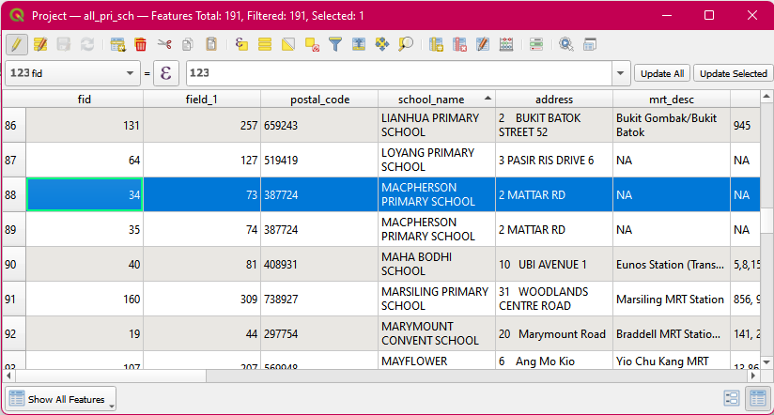

1. Disable the *Toggle Editing* tool to save the changes made

## Creating closed_primary_schools layer

From the at*tribute table* of **all_primary_schools,** select the 7 closed primary schools (Balestier Hill Primary School, Coral Primary School, Da Qiao Primary School, East Coast Primary School, East View Primary School, Loyang Primary School, and Macpherson Primary School) that have already been added in. This can be done quicker by filtering the *school_name* field.

After the 7 closed schools have been selected, we can *save the Selected Features* into the **Project** GeoPackage and name the new layer as closed_primary_schools**.**

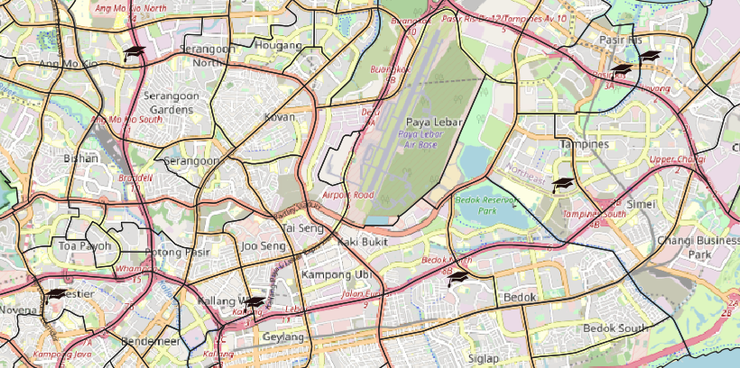

## Creating current_primary_schools layer

From the attribute table of **all_primary_schools,** we can click on the *Invert Feature Selection* button that wouldselect the other183 primary schools.

After the 183 schools have been selected, we can *Save Selected Features As* **current_primary_schools** into the **Project** GeoPackage

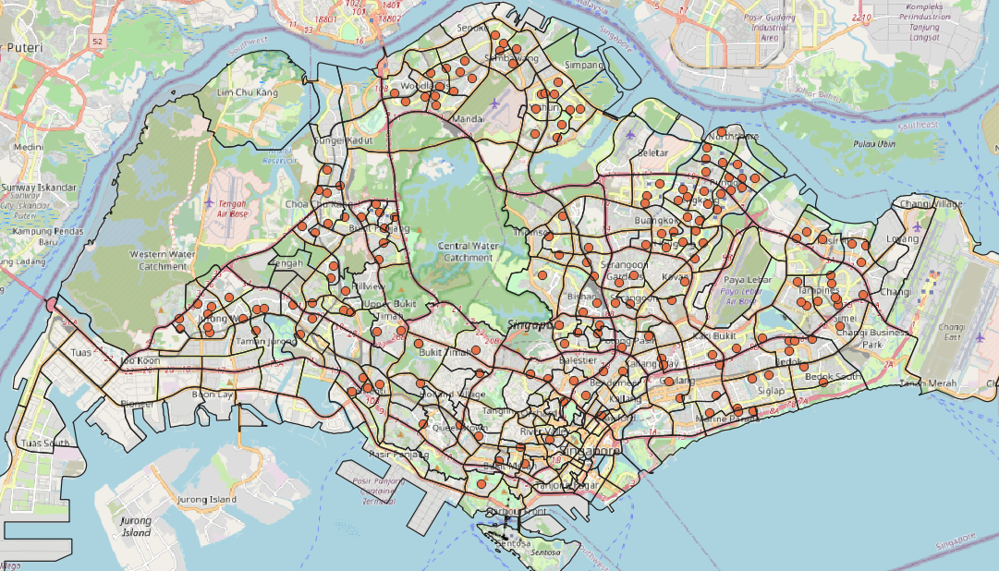

## Creating Choropleth Map of Schools in Each Subzone

1. Under Vector menu bar, select Analysis Tools -> Count Point in Polygon
2. Enter the following inputs

* Ensure to set Invalid feature filtering to Do Not Filter (Better Performance)

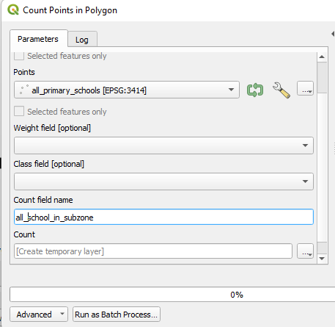

1. Save the temporary file, **Count**, as **all_school_in_subzone**
2. Double-click on **all_school_in_subzone,** select **Symbology**
3. Select **Categorized**

* Value: all_school_in_subzone

1. Click on Classify
2. Change the Symbol for Value 0 to white

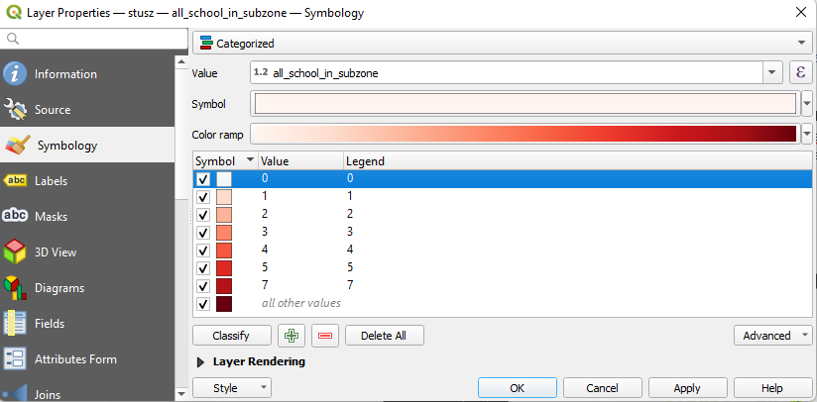

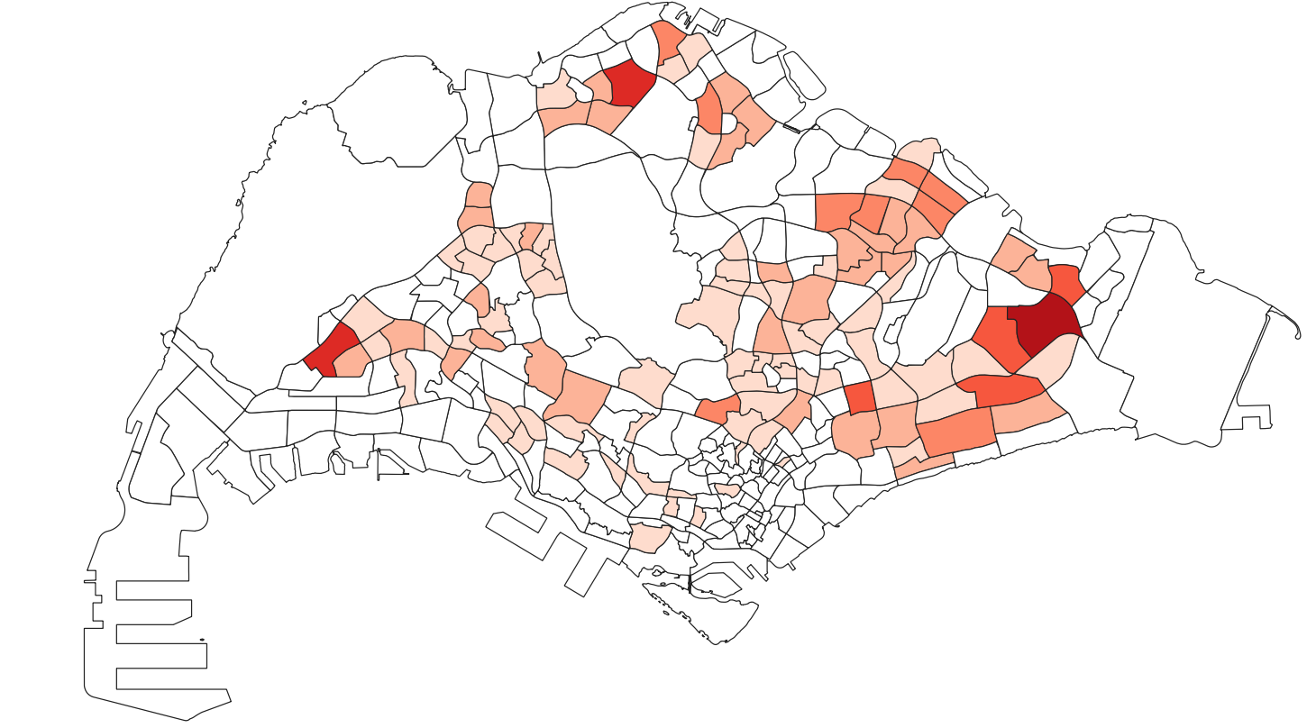

## Creating walking layer

1. Load **gis_osm_roads_free_1.shp** onto your Layers panel
2. Save it in 3414 projected system as **roads_3414** into your **Project** GeoPackage
3. Use *Select by Location tool* to select all the roads in mainland layer
4. Save Selected Features As **all_roads** into your **Project** GeoPackage
5. Open the attribute table of **all_roads**
6. Use *Select Features by Expression* tool and enter the following

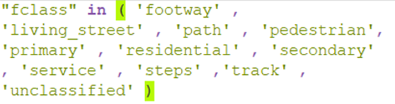

1. Save Selected Features As **walking** into your **Project** GeoPackage

## Creating privatedriving layer

1. Open the attribute table of **all_roads**
2. Use *Select Features by Expression* tool and enter the following

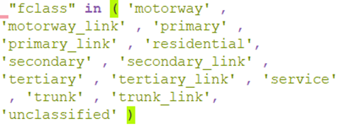

1. Save Selected Features As **privatedriving** into your **Project** GeoPackage

## Creating hex_residentials and hex_residentials_centroids layer

1. Load **gis_osm_landuse_a_free_1.shp** onto Layers panel
2. Save it in 3414 projected system as **landuse_3414** into your **Project** GeoPackage
3. Use *Select Features by Expression* tool to filter only residentials
4. *Save Selected Features* As **residential_landuse** into your **Project** GeoPackage
5. Use *Select by Location* tool to select all the residentials in **mainland**

* Ensure to set Invalid feature filtering to Do Not Filter (Better Performance)

1. *Save Selected Features* as **mainland_residential_landuse**
2. Under the Vector menu bar, select *Research Tools -> Create Grid*. Fill up the following

* For Grid extent, select **mainland_residential_landuse**

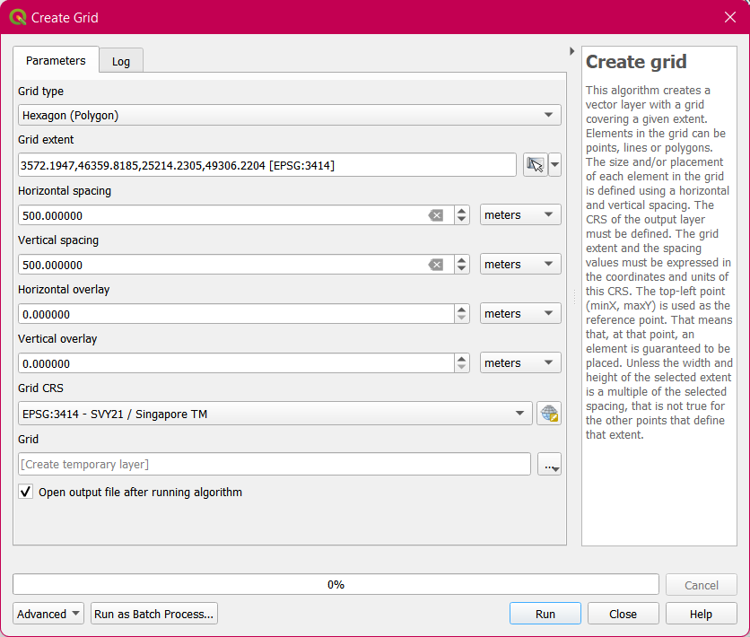

1. A temporary layer, **Grid**, appears under Layers panel
2. Use Select by *Location* tool to select all the hexagons in the temporary layer, **Grid**, that intersect with **mainland_residential_landuse**

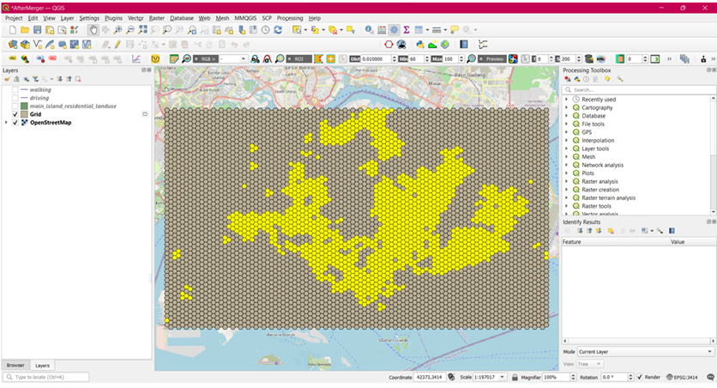

1. *Save Select Features* As **hex_residentials** into your **Project** GeoPackage
2. Remove temporary layer, **Grid** from Layers panel
3. Under the Vector menu bar, select *Geometry Tools -> Centroids*.

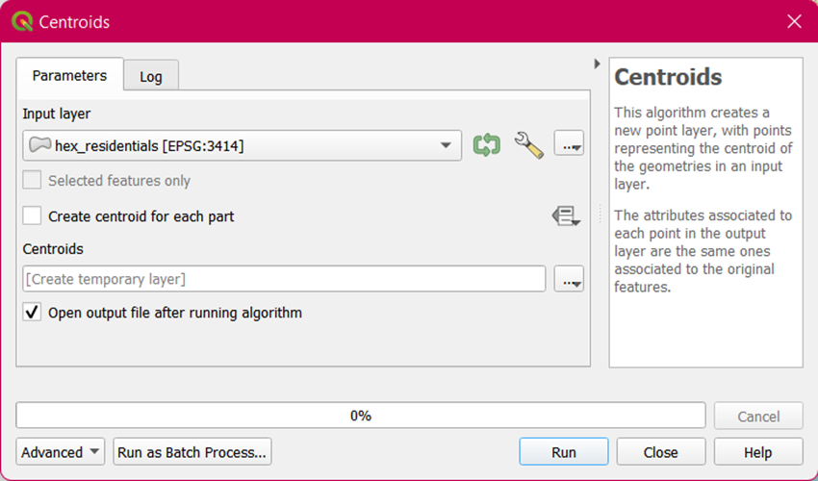

1. Save temporary layer, **Centroids**, as **hex_residentials_centroids** into your **Project** GeoPackage
2. Remove the temporary layer, **Centroids**, from your Layers panel. Below is how your QGIS active window would look like if the centroids are successfully created

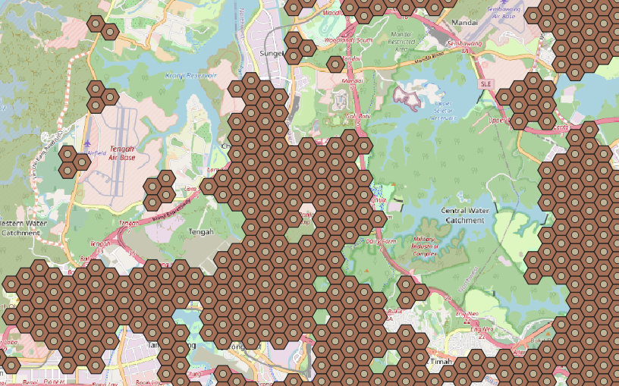

# Data Cleaning

## Find the Relative Student to School Ratio in Subzones

From the 2 choropleth maps of students (in blue) and schools (in red) distribution in each subzone, we will create print layouts for each and export them as JPG files.

Using external tools such as Photoshop or other photo editing software, overlay the 2 maps on top of each other and change the layer blend mode to multiply. The resulting image should look like this.

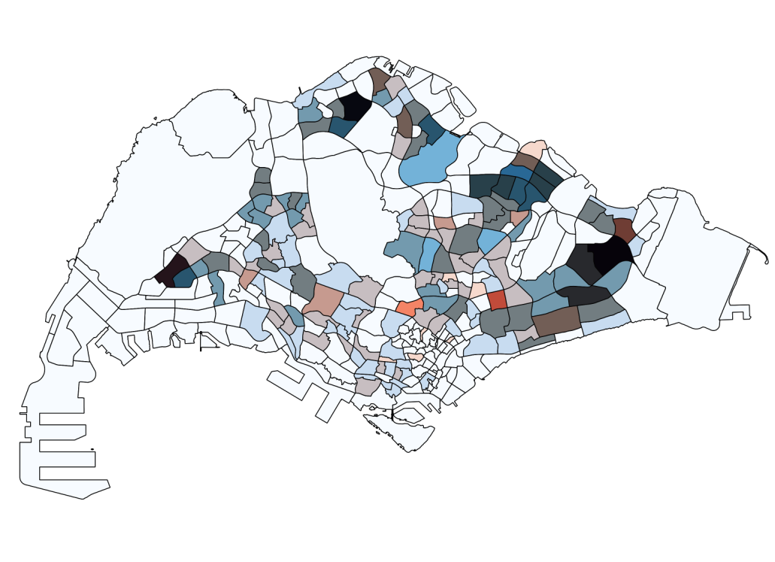

## Find the Number of Affected Residentials

a. Buffer

The first method we will use to find the affected residentials of the closure of schools will be by using the buffering method.

1. Under the Vector menu bar, select Geoprocessing Tools -> Buffer
2. Enter the following inputs

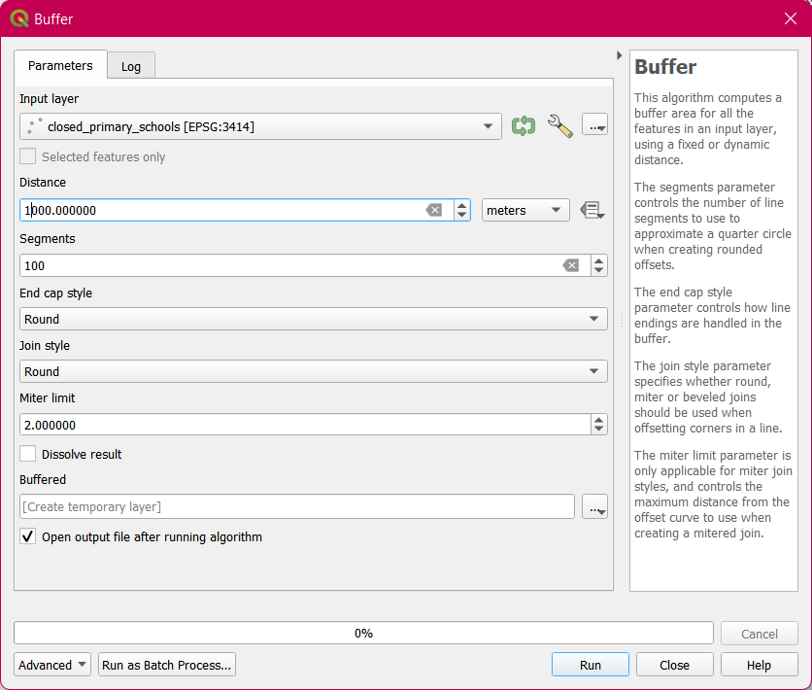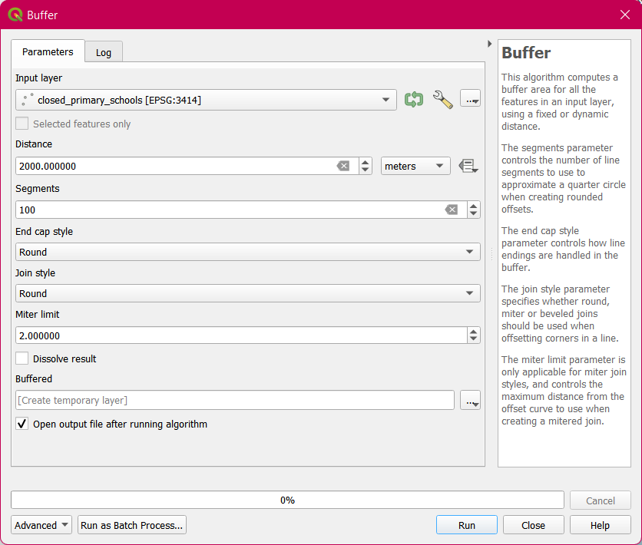

1. 2 temporary **Buffered** layers have been added to your Layers panel
2. Export these layers into the **Project** GeoPackage and name the new layers as **closed_1kmb** and **closed_2kmb** respectively

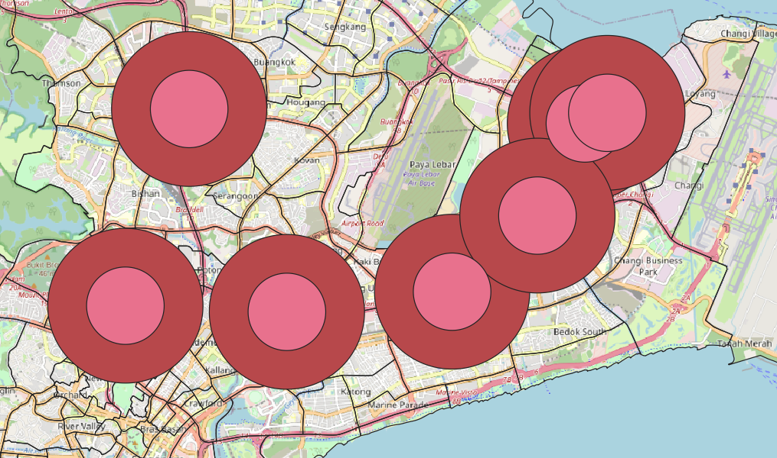

1. Remove the 2 temporary layers from your Layers panel
2. Click on **hex_residentials_centroids** to activate the layer
3. Using the *Select Features by Radius* tool, select the centroids that lie within all the buffer zones surrounding the closed schools
4. Save the layers respectively as **1km_affected** and **2km_affected** into your **Project** GeoPackage

b. QNEAT3

i. Shortest Path

The second method we will use to find the affected residentials of the closure of schools will be by using the shortest path method.

1. Under Processing Toolbox, search for QNEAT3
2. Select the *Iso-Area as Polygons (from Layer)*

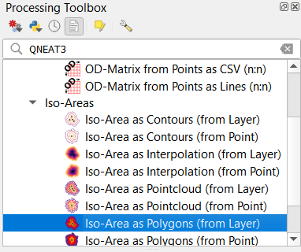

Since we are trying to find the shortest path of 1km and 2km respectively, for two modes of transport – by walking and by private transport, we will be creating a total of 4 pairs of output polygon and interpolation layers. We will only save the output polygons into our **Project** GeoPackage.

As these layers have many parameters that need to be kept to, the important inputs will be listed down in the table below:

|  |  |  |  |  |
| --- | --- | --- | --- | --- |
| Layer name to save into **Project** geopackage | **1km_SP(private)** | **1km_SP(walking)** | **2km_SP(private)** | **2km_SP(walking)** |
| Vector layer representing network | PrivateDriving [EPSG: 3414] | Walking [EPSG: 3414] | PrivateDriving [EPSG: 3414] | Walking [EPSG: 3414] |
| Start Points | closed [EPSG: 3414] | | | |
| Unique Point ID Field | fid | | | |
| Size of Iso-Area (distance or time value) | 1000 | | 2000 | |
| Contour Interval (distance or time value) | 1000 | | 2000 | |
| Path type to calculate | Shortest Path (distance optimization) | | | |
| Direction field | oneway | | | |
| Value for forward direction | F | | | |
| Value for backward direction | T | | | |
| Value for both directions | B | | | |

The following is a screenshot of how all 4 layers look like on our active QGIS window: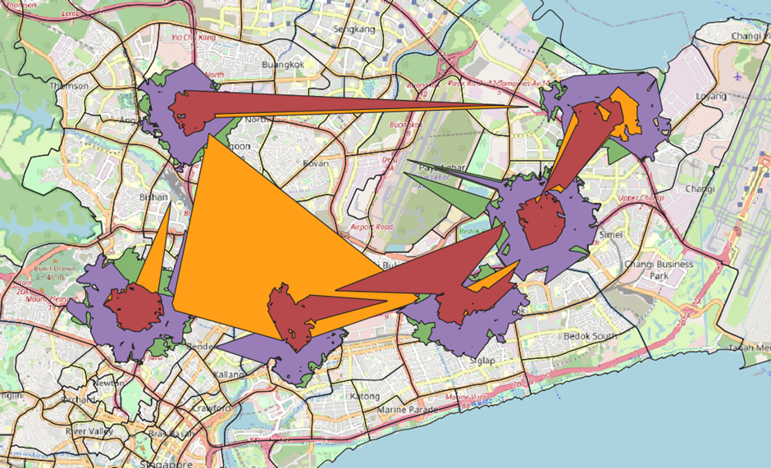

ii. Fastest Time

The third method we will use to find the affected residentials of the closure of schools will be by using the fastest time method.

1. Under Processing Toolbox, search for QNEAT3
2. Select the *Iso-Area as Polygons (from Layer)*



Since we are trying to find the fastest time of approximately 1km and 2km respectively, for two modes of transport – by walking and by private transport, we will be creating a total of 4 pairs of output polygon and interpolation layers. We will only save the output polygons into our **Project** GeoPackage.

As these layers have many parameters that need to be kept to, the important inputs will be listed down in the table below:

|  |  |  |  |  |
| --- | --- | --- | --- | --- |
| Layer name to save into **Project** geopackage | **1km_FT(private)** | **1km_FT(walking)** | **2km_FT(private)** | **2km_FT(walking)** |
| Vector layer representing network | PrivateDriving [EPSG: 3414] | Walking [EPSG: 3414] | PrivateDriving [EPSG: 3414] | Walking [EPSG: 3414] |
| Start Points | closed [EPSG: 3414] | | | |
| Unique Point ID Field | fid | | | |
| Size of Iso-Area (distance or time value) | 90 | 720 | 180 | 1440 |
| Contour Interval (distance or time value) | 90 | 720 | 180 | 1440 |
| Path type to calculate | Fastest Path (time optimization) | | | |
| Direction field | oneway | | | |
| Value for forward direction | F | | | |
| Value for backward direction | T | | | |
| Value for both directions | B | | | |
| Speed Field | speed | - | speed | - |
| Default Speed | - | 5km/h | - | 5km/h |

The following is a screenshot of how all 4 layers look like on our active QGIS window:

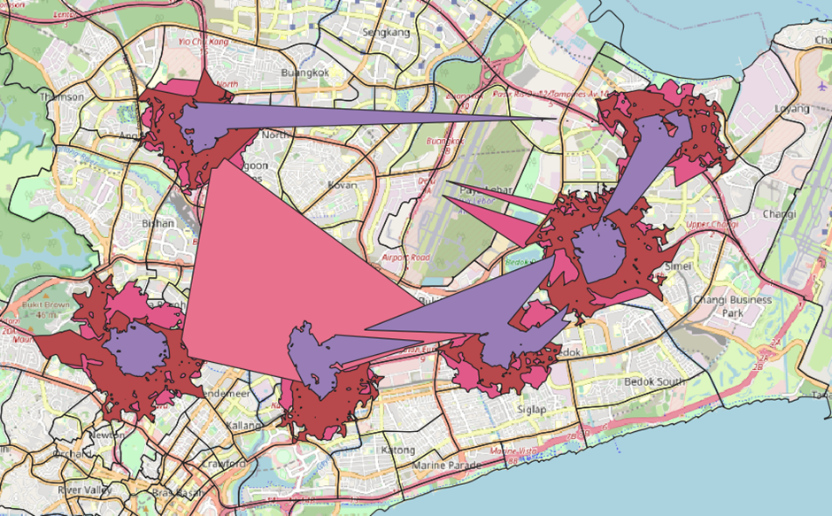

iii. Average out SP & FT

After we have created all 8 different layers via the shortest path and fastest time with QNEAT3, we can calculate the number of affected residentials in each layer.

1. Click on **hex_residentials_centroids** to activate the layer
2. Using the *Select Features by Freehand* tool, trace the shape of each output polygon layer that corresponds to the area around each closed school to find the number of residential centroids affected

After finding the number of affected centroids, we can manually input these values into the **closed_schools** CSV file. The CSV file should look something like this:

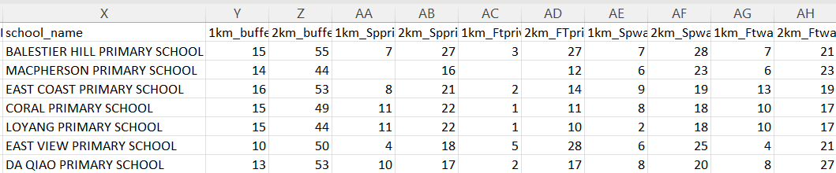

As these 2 methods are similar, we can average the two methods to obtain the average number of residentials that have been affected.

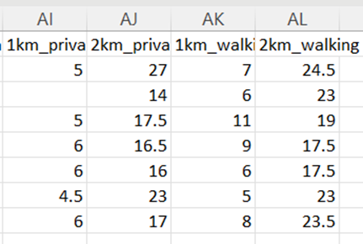

From the 88 and 290 affected residential centroids obtain within the 1km and 2km buffer respectively, we will first count the number of primary schools accessible via buffers, shortest path by walking and shortest path by driving before and after merger. Afterwards, we will derive the percentage change.

For each residential centroid, let’s create

1. A 1km buffer
2. A 2km buffer
3. A 1km shortest network path by walking
4. A 2km shortest network path by walking
5. A 1km shortest network path by driving
6. A 2km shortest network path by driving

## Create Buffers for Affected Residentials

Under Vector menu bar, select *Geoprocessing Tools -> Buffer*. You will create two buffers each for **1km_affected** and **2km_affected.** Fill in the following under Parameters for each of the buffer layer

|  |  |  |  |  |
| --- | --- | --- | --- | --- |
| Layer name to save into **Project** geopackage | **1kma_1kmb** | **1kma_2kmb** | **2kma_1kmb** | **2kma_2kmb** |
| Input layer | 1km_affected [EPSG: 3414] | 1km_affected [EPSG: 3414] | 2km_affected [EPSG: 3414] | 2km_affected [EPSG: 3414] |
| Distance | 1000 | 2000 | 1000 | 2000 |
| Segments | 100 | | | |
| End cap style | Round | | | |
| Join style | Round | | | |

## Create Shortest Paths for Affected Residentials

1. Under *Processing Toolbox*, search for network and select the built-in tool, *Service area (from layer)*. You will create 4 temporary pairs of Service area (line) layers and Convex hulls layers each for **1km_affected** and **2km_affected**

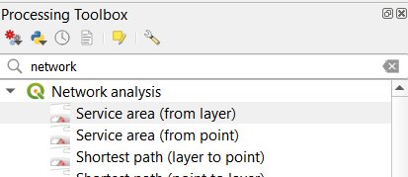

1. Enter the following under *Parameters* for each of the temporary service area layer

|  |  |  |  |  |  |  |  |  |
| --- | --- | --- | --- | --- | --- | --- | --- | --- |
| Layer name to save into **Project** geopackage | **1kma_** | | | | **2kma_** | | | |
| **1kmshort_walking** | **2kmshort_walking** | **1kmshort_driving** | **2kmshort_driving** | **1kmshort_walking** | **2kmshort_walking** | **1kmshort_driving** | **2kmshort_driving** |
| Vector layer representing network | Walking [EPSG: 3414] | | PrivateDriving [EPSG: 3414] | | Walking [EPSG: 3414] | | PrivateDriving [EPSG: 3414] | |
| Path type to calculate | Shortest | | | | | | | |
| Vector layer with start points | 1km_affected [EPSG:3414] | | | | 2km_affected [EPSG:3414] | | | |
| Travel cost | 1000 | 2000 | 1000 | 2000 | 1000 | 2000 | 1000 | 2000 |
| Direction field | oneway | | | | | | | |
| Value for forward direction | F | | | | | | | |
| Value for backward direction | T | | | | | | | |
| Value for both directions | B | | | | | | | |

Below is an example of how your temporary **Service area (lines)** layer will look like:

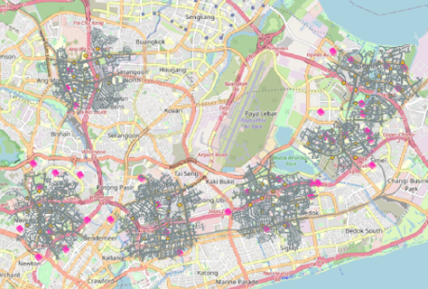

1. After each temporary **Service area (lines)** layer is added to your Layers panel, search for convex under *Processing Toolbox* and select *Convex hull*

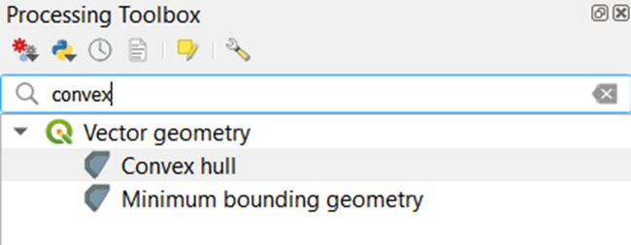

1. Select **Service (area) lines** as your Input layer and click Run
2. Another temporary layer, **Convex hulls**, is created under Layers panel

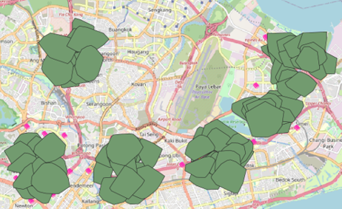

1. Save the above layer as **1kma_1kmshort_walking** into your **Project** GeoPackage.
2. Remove both temporary layers, **Service area (lines) and Convex hulls** from your Layers panel
3. Do the same for another 7 times, using parameter inputs as shown in the above table

## Find and Calculate the Number of Primary Schools Accessible by Buffers (1km_affected)

Under the Vector menu bar, select *Analysis Tools -> Count Points* in Polygon. You will create two pairs of primary school count, one (consisting of all and curr) for each buffer

|  |  |  |  |  |
| --- | --- | --- | --- | --- |
| Polygons | 1kma_1kmb [EPSG: 3414] | | 1kma_2kmb [EPSG: 3414] | |
| Points | all_primary_schools [EPSG: 3414] | current_primary_schools [EPSG: 3414] | all_primary_schools [EPSG: 3414] | current_primary_schools [EPSG: 3414] |
| Count field name | all | curr | all | curr |

1. Rename the temporary layer, **Count**, as

* all when your input for Points is all
* curr when your input for Points is curr

1. Open the Layer Properties window for **1km_affected**
2. Click on Joins and then the green + icon
3. Enter the following inputs

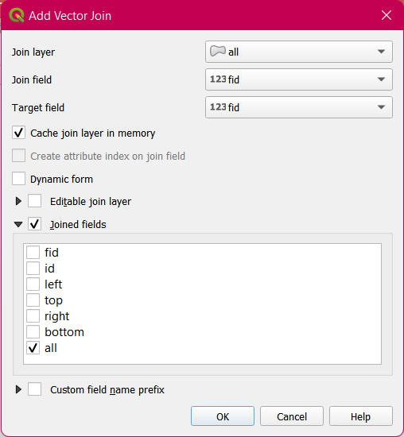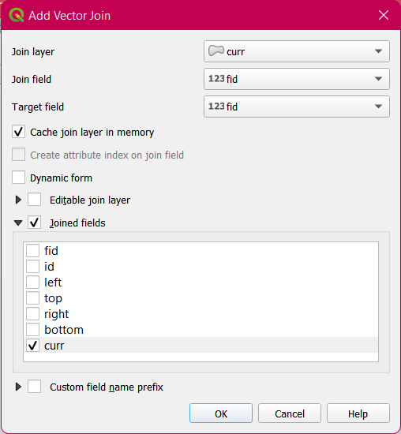

1. Notice that the attribute table of **1km_affected** will have 2 new fields, curr_curr and all_all.

You will now create a new field, **1KM_BUFF_PERC_CHANGE**

1. Open your *field calculator* tool and enter the following expression

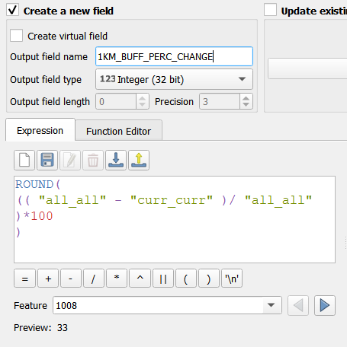

1. Update the NULL values in your newly created field with the following expression

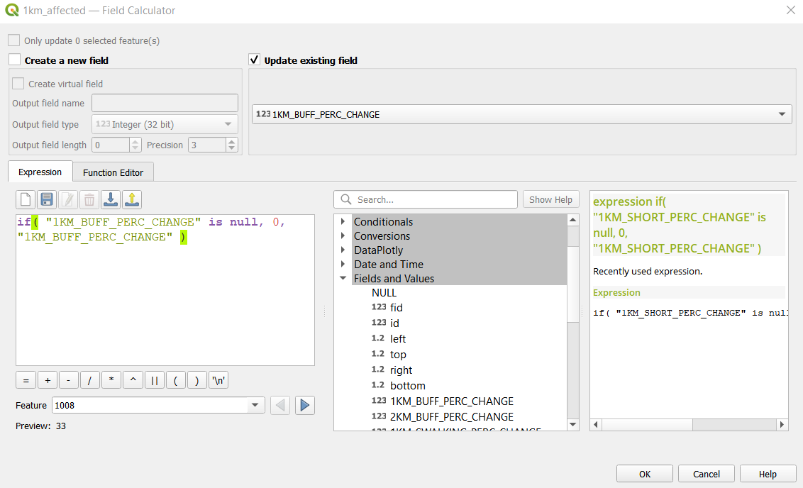

1. Remove curr and all from your Layers panel
2. Repeat the above steps to create a new field, **2KM_BUFF_PERC_CHANGE**

## Find and Calculate the Number of Primary Schools Accessible by Walking the Shortest (1km_affected)

Under the Vector menu bar, select *Analysis Tools -> Count Points in Polygon*. You will create two pairs of primary school count, one (consisting of all and curr) for each walking polygon

|  |  |  |  |  |
| --- | --- | --- | --- | --- |
| Polygons | 1kma_1kmshort_walking [EPSG: 3414] | | 1kma_2kmshort_walking [EPSG: 3414] | |
| Points | all_primary_schools [EPSG: 3414] | current_primary_schools [EPSG: 3414] | all_primary_schools [EPSG: 3414] | current_primary_schools [EPSG: 3414] |
| Count field name | all | curr | all | curr |

With the steps above, create **1KM_SWALKING_PERC_CHANGE** and **2KM_SWALKING_PERC_CHANGE**

## Find and Calculate the Number of Primary Schools Accessible by Driving the Shortest (1km_affected)

Under the Vector menu bar, select *Analysis Tools* -> *Count Points in Polygon*. You will create two pairs of primary school count, one (consisting of all and curr) for each driving polygon

|  |  |  |  |  |
| --- | --- | --- | --- | --- |
| Polygons | 1kma_1kmshort_driving [EPSG: 3414] | | 1kma_2kmshort_driving [EPSG: 3414] | |
| Points | all_primary_schools [EPSG: 3414] | current_primary_schools [EPSG: 3414] | all_primary_schools [EPSG: 3414] | current_primary_schools [EPSG: 3414] |
| Count field name | all | curr | all | curr |

With the steps above, create **1KM_SDRIVING_PERC_CHANGE** and **2KM_SDRIVING_PERC_CHANGE**

At the end, the attribute table of **1km_affected** should look like the following:

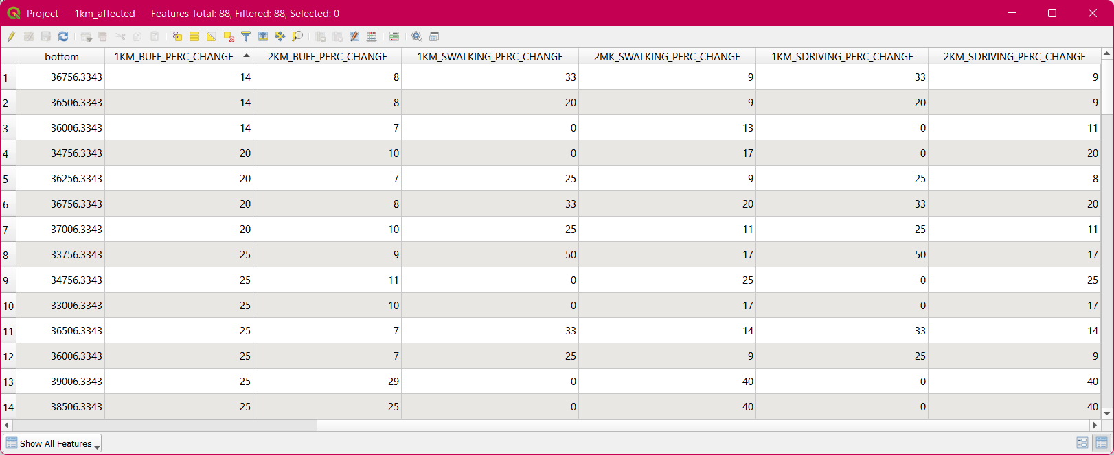

Now that you have finished creating all 6 new fields, repeat all the steps from the above 3 sub-sections for **2km_affected**.

Results and Discussion

# Data Analysis

## Subzone Analysis of Students to School Ratio



The number of primary schools are represented by red hue, and the number of primary school students are represented by blue hues. Therefore, the redder hue on the final image indicates that there are more schools in that particular subzone compared to the relative number of students in the subzone. Vice versa, the bluer the hue, the more student to school in the subzone. The darker regions indicate that there are a lot of schools as well as a lot of students in the subzone. Analysis also shows that the Malcom subzone has a lot of schools but relatively a lot fewer student count.

|  |  |
| --- | --- |
| Subzone with the most number of students | Woodlands East (1150), Tampines East (1130) |
| Subzone with the most number of schools | Tampines East (7), Yunnan (5), Woodlands East (5) |

According to Statista, the enrolment has been showing a downward trend since 2011 and only sees a small spike in 2019.



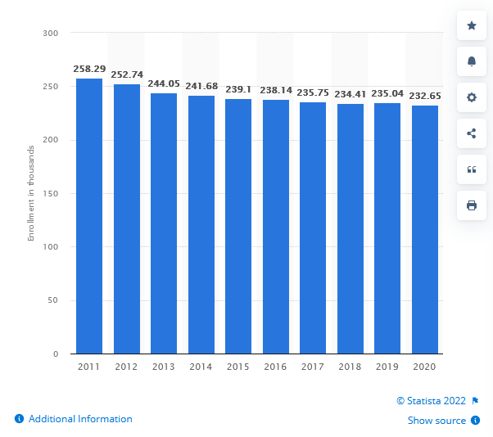

This data is in line with the data for declining birthrate since 2015 as shown below.

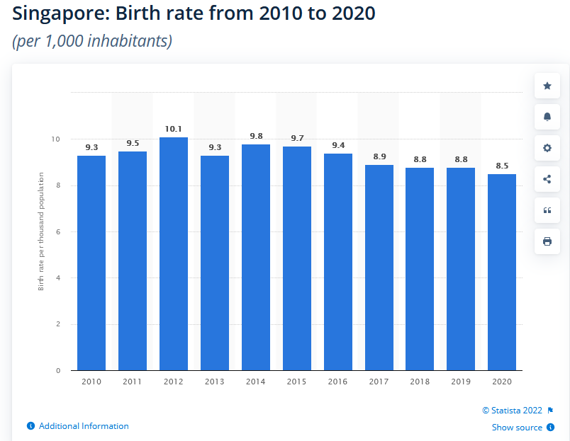

In the table taken from Education Statistics Digest 2020, we can see the enrolment number and number of classes with average class size for 2019.

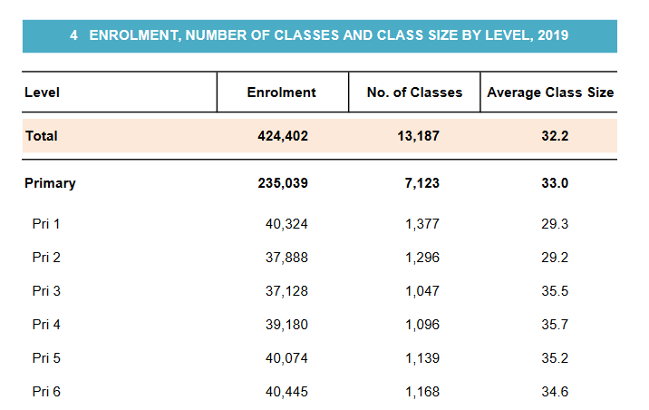

Therefore, with a downward trend of students in schools coupled with declining birth rate, it is reasonable for schools to close/merge to provide quality education to the students.

## Number of Affected Residentials due to Merger

In order to clearly analyze the number of affected residentials due to the closure of the 7 primary schools in 2019, the data that has been manually calculated from the data collection portion of this study has been imported into a Python file so that the data will be more clearly represented. This screenshot below shows a data frame of the affected residentials:

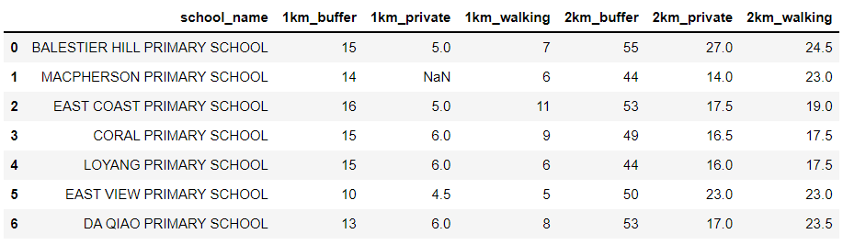

Since the buffer zone covers a greater area as compared to the output polygons created from QNEAT3, there is a larger number of affected residentials represented by the buffer zone and is about 2 to 3 times as large as the number of residentials represented by the output polygons.

When looking from the 1km proximity distance from the closed schools, the closure of schools could affect up to 16 residential areas (taken from the closure of East Coast Primary School). When looking from the 2km proximity distance from the closed schools, the closure of schools could affect up to 55 residential areas (taken from the closure of Balestier Hill Primary School). From just looking at the data collected by using the buffer method, an average of 14 and 50 residential areas are affected within a 1km and 2km buffer respectively.

With 3 closures in the East, 3 closures in the Central and 1 closure in the North, we have taken a closer look at the subzone analysis that we have previously done. In the Eastern region of Singapore nearer towards the Tampines and Pasir Ris subzones, the proportion of schools to students in these areas are one of the greatest as compared to the other subzones of Singapore. By closing 3 schools, this would make sense to reduce the school count and balance the ratio of schools to students in the area. In the Central region and especially where East Coast Primary School and Macpherson Primary School were once located, the subzones also mostly show a larger proportion of schools to students, which does correspond to the government’s decision to close these 2 schools. However, Balestier Hill Primary School (located centrally) and Da Qiao Primary School (located in the North) have subzones where the ratio of schools to students are roughly equal as compared to all the subzones in Singapore. By using the same deduction, the closure of these 2 schools would result in a higher student to school ratio, equating to a lack of access to schools in these subzones due to high enrolment rates (assuming students apply for schools near their residential areas).

## Number of Schools Accessible After the Merger

We also wanted to quantify the impact of school closures for each residential centroid, specifically looking at the change in the number of primary schools accessible based on a transport mode. As the top 2 transport modes of primary school students were by walking and driving (https://www.singstat.gov.sg/find-data/search-by-theme/population/mode-of-transport/visualising-data/mode-of-transport-dashboard), we looked at both. We looked at the percentage change (reduction), instead of the absolute difference as it gives a more accurate representation of how residents are affected.

Of the 88 affected residentials that are within 1km proximity of the closed primary schools, we discovered that 3/5 of them still have the same number of primary schools accessible, by walking, within 1km from where they live (ie a change of 0%). A tenth of them had to walk beyond 1km but not more than a driving distance of 2km. An interesting note is that due to the short distance travelled, the change in accessibility did not vary much between the two different transport modes. One obvious difference between walking and driving is that the residentials who walked had a greater proportion of more than 50% reduction in accessibility. This means that while there is some disruption to the residents’ accessibility, the impact is not too great.

|  |  |  |  |  |
| --- | --- | --- | --- | --- |
|  | 1km_affected (88) | | | |
| Percentage change (%) | 1km walking | 2km walking | 1km driving | 2km driving |
| 0 | 50 | 6 | 53 | 7 |
| 100 | 9 | 2 | 8 | 0 |
| >=50 | 29 | 17 | 19 | 1 |

Of the 288 affected residentials that are within 2km proximity of the closed primary schools, there is undoubtedly a larger proportion of them being unaffected by the closures as compared to the residentials above. The only proportion that remained unchanged is when the travelling distance is 1km.

|  |  |  |  |  |
| --- | --- | --- | --- | --- |
|  | 2km_affected (288) | | | |
| Percentage change (%) | 1km walking | 2km walking | 1km driving | 2km driving |
| 0 | 150 | 131 | 161 | 5 |
| 100 | 9 | 3 | 8 | 0 |
| >=50 | 22 | 7 | 19 | 1 |

# Limitations

## Calculation of Affected Residentials

The first limitation of this method is that due to human error of tracing the polygon, the number of residential centroids may differ slightly from each user to another user. In order to reduce this error, we can zoom in to the polygon as close as we can to trace the shape as accurately as possible. The second limitation is that the distance between two schools may be so close that the polygons may intersect one another, which would lead to inaccurate results. In order to reduce this limitation, we can try to find an equal distance between both schools and split the polygon into half.

## Use of (Centroids of) Hexagonal Grids to Represent Affected Residentials

By using hexagonal grids to represent groups of residential landuse areas on the mainland layer, it creates an inaccuracy of the number of residential buildings that have truly been affected by the closure of the schools. In addition, even though some parts of the grid may be covered by the buffer or output polygons, the hexagonal grid will not be selected if the centroid does not overlap. Therefore, the size of the hexagonal grid used is a limitation that we had to consider as assigning a centroid to each residential landuse area/building would have been computationally too intensive.

## Method of finding Shortest Path and Fastest Time

A limitation of this method that we encountered was that some of the output polygons that we produced were abnormal in terms of how it was formed on the map. This resulted in inaccurate data that was produced for the number of affected residentials. This meant that the data had to be represented by NA. A possible alternative would be to use the Distance Interval method, but it is also computationally intensive.

# Lessons Learnt

Tristan’s:

* Geospatial Analysis is an essential tool for human visualization of the number of schools that are in someone’s proximity area, and how fortunate Singaporeans are that their children have relatively easy access via walking or private transport to schools
* Most subzones in Singapore have a higher proportion of schools to students, which also show how students currently will most likely be able to enroll into a school in their residential area. This also shows why the government may be closing some schools in order to ensure that the ratio of schools to students is not too large
* In order to maintain the equity of enrolment and registration of P1 students into schools, residentials that have no or limited access to schools due to the closure of schools within a certain proximity distance should be given priority in terms of enrolment and registration.

Mahn Yin’s:

* Having done the analysis on the subzone and primary school made me appreciate the meticulous planning done by the relevant parties even more
* Accessibility to schools should not be taken for granted – every child in Singapore is guaranteed access to education, yet some countries struggle to provide education for even a fraction of their children.

Jia Xuan’s:

* Accessibility to schools can be measured in different metrics. My project group decided to focus on one metric, which is the number of points (schools/residential centroids). Despite having only one metric, we approached itfromn two different perspectives for a deeper insight into our chosen subtheme. This reminded me of how there will always be different perspectives to a single subject, and we should never stick to just one
* There would always be unfairness in any decision, as shown in how some residentials were affected more by the school closures than others. Tradeoffs will also be incurred, but they can be balanced out

# Future Works

* With Singapore expanding her bus and train networks, our work can be extended to include an analysis of students’ accessibility via public transport
* With past and future closures/mergers before and beyond 2019 respectively, future work can be done to identify possible patterns as to why closures and mergers happen in designated subzone areas around Singapore
* Looking at mergers and closures of other educational institutions such as secondary schools and junior colleges, and analyze if the extent of decreased accessibility is greater or lesser for these institutions could be an extension of our current work
* Able to explore the correlation between different demographic groups and their accessibility to schools due to mergers and closures

References

<https://gis4urbplan.netlify.app/hands-on_ex10#analytical-hexagon>

<https://www.cadlinecommunity.co.uk/hc/en-us/articles/4402895570449-QGIS-Network-Analysis-Service-Areas-from-Layer->

<https://www.moe.gov.sg/-/media/files/about-us/education-statistics-digest-2020.pdf?la=en&hash=C5E45EEA6E424D9749F617A4D88A171F6E20AB9A>

<https://www.statista.com/statistics/977233/crude-birth-rate-in-singapore/>

<https://www.statista.com/statistics/624323/enrollment-in-primary-schools-in-singapore/>

<https://www.singstat.gov.sg/find-data/search-by-theme/population/mode-of-transport/visualising-data/mode-of-transport-dashboard>